HEIGHTS HOTEL WILDLIFE BREAKS
Friday November 2nd – Sunday November 4th 2018

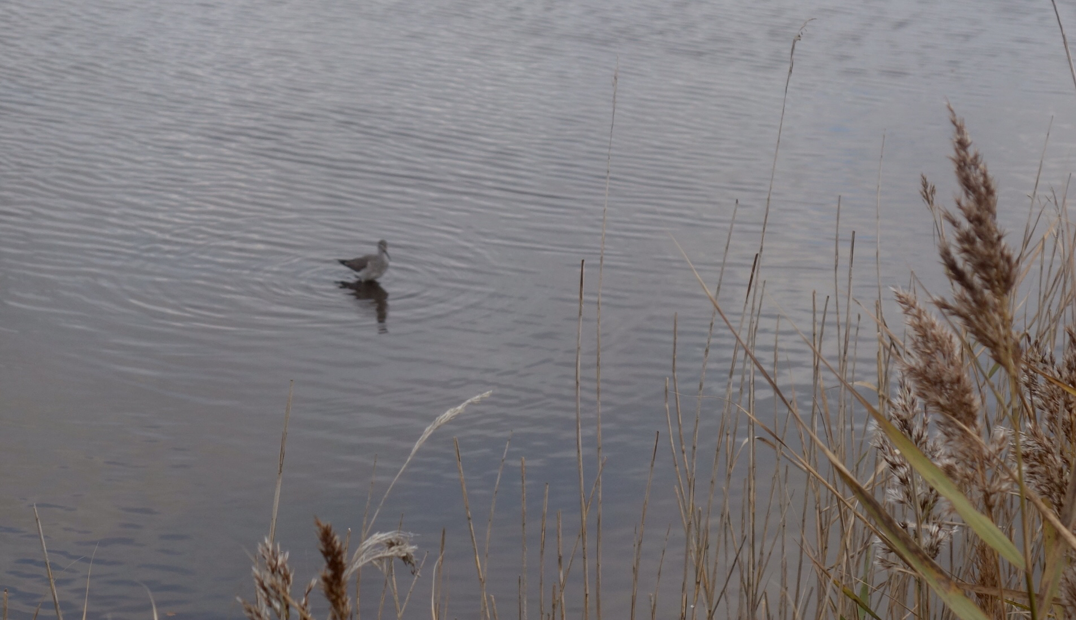
Lesser Yellowlegs at Lodmoor (photo by Bob Ford)

Saturday November 3rd
Weather: Mostly bright and dry but in a strong southerly windy

Portland Bill, 0900
In very windy conditions we explored the most southerly point of Dorset seeing good numbers of Gannets and Kittiwakes flying east some distance offshore along with Cormorants and Shags closer in. A Glaucous Gull flying past escaped detection by all but one of us but was later seen by a number of local birders.

Walking along the Eastcliffs towards the Bird Observatory we had good views of Rock Pipits, Turnstone and Oystercatcher on the shore. At the Observatory the Warden, Martin Cade, showed us the night’s moth catch which included a couple of very rare Flame Brocades. As we left a Peregrine appeared overhead and proceeded to chase the Wood Pigeons in the ancient strip lynchet field system.

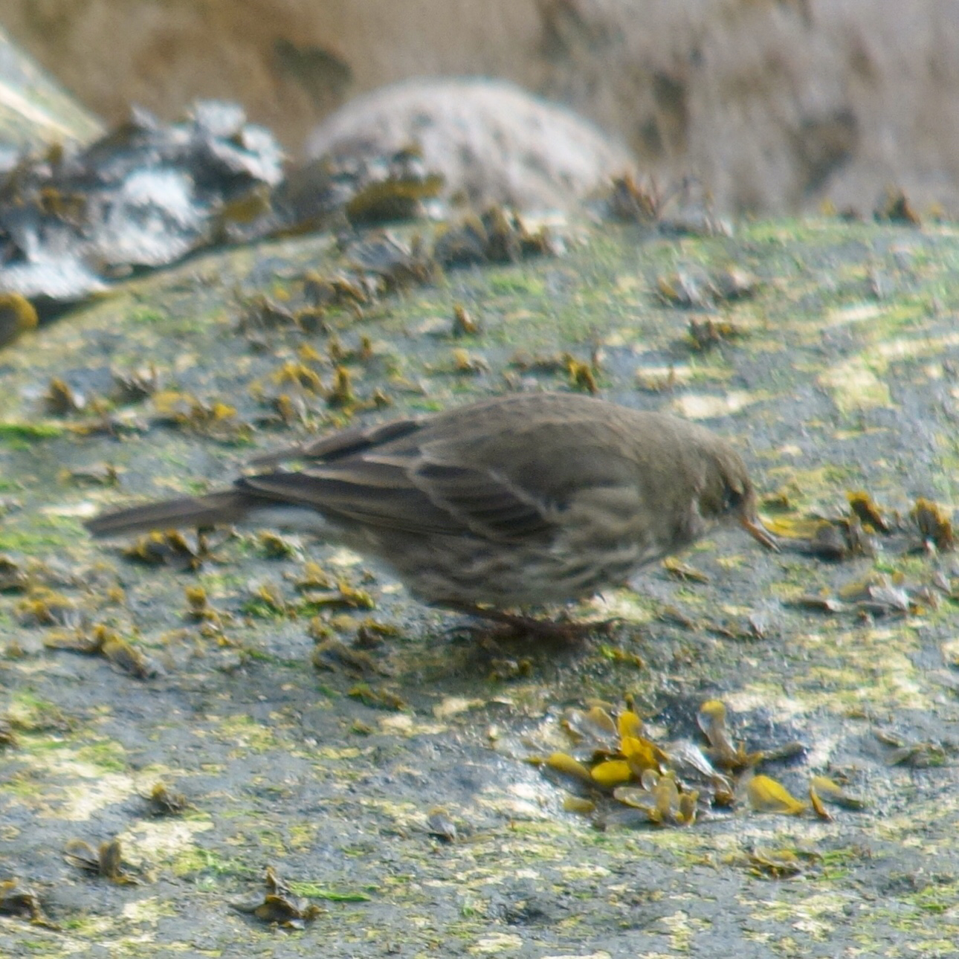 | 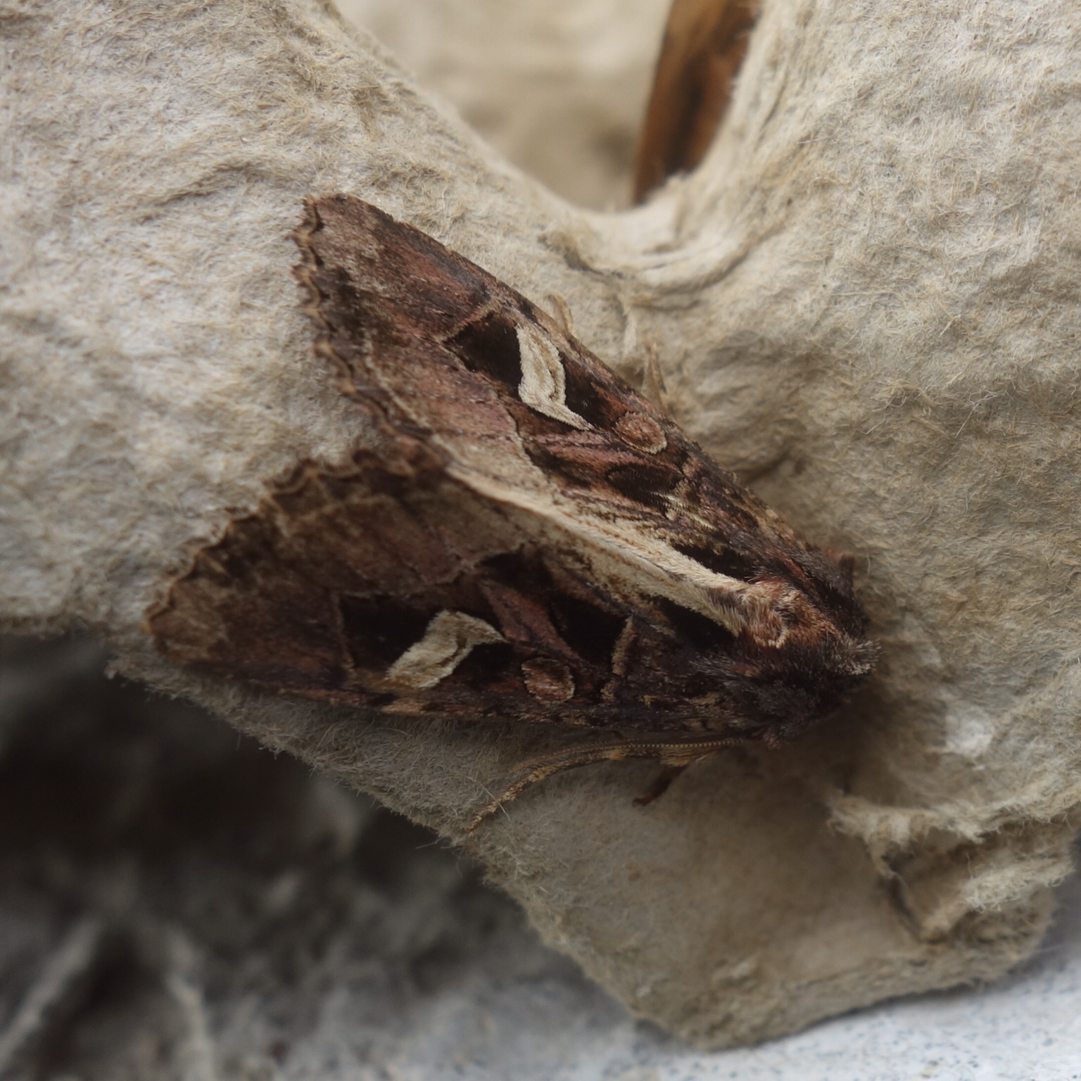
Rock Pipit  (photo by Bob Ford) | Flame Brocade  (photo by BobFord)

Grove Stadium, 1100
Our search for the elusive Yellow-browed Warbler produced no more than a few distant calls and glimpses of birds that may or may not have been our target. Hearing that the Glaucous Gull had been seen flying in our direction we searched the sea from the lookout at Grove Point but again to no avail.

Ferrybridge, 1230
In improving conditions we enjoyed excellent views of a Little Egret from the van with a flock of five or more Skylarks on the shoreline. In the distance on Chesil Beach fifty or so Ringed Plovers could be seen sitting out the high tide along with several Dunlins. The mudflats held no less than six species of gull including single Lesser Black-backed and Mediterranean Gulls.

Lodmoor RSPB Reserve, 1330
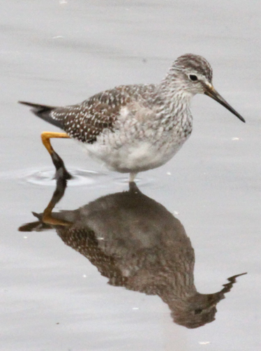
This excellent reserve produced the star sighting of the weekend when the Lesser Yellowlegs appeared just in front of us, feeding just a few metres away. Many other waders were seen as well including Greenshank, Snipe and Black-tailed Godwit.
Lesser Yellowlegs (photo by John Thompson)

Radipole RSPB Reserve, 1500
A quick stop here to look for some Scaup that had been sighted earlier instead produced a very unusual looking duck that was most likely a hybrid between Tufted Duck and Ring-necked Duck. Whilst we were puzzling over this individual a pair of Marsh Harriers appeared hunting over the reeds. Cetti’s Warblers and Water Rails were heard on the way back to the car park, where a group of five Snipe were seen feeding at the edge of the gull flock.
***STOP PRESS*** our “hybrid duck” has now been confirmed as a first winter male Ring-necked Duck
***UPDATE*** two weeks later I’ve finally managed to get some photos of it, see http://www.natureportfolio.co.uk/birdbreaks/2018/nov18/ring-necked-duck.php

Portland Bill, 1600
Our final mission was to look for the Short-eared Owls that have been seen hunting over the Admiralty Slopes near the Bill. The conditions proved too windy this afternoon but we did see a Buzzard and a number of Kestrels.

Sunday November 4th
Weather: wet in the morning but dry and calm in the afternoon
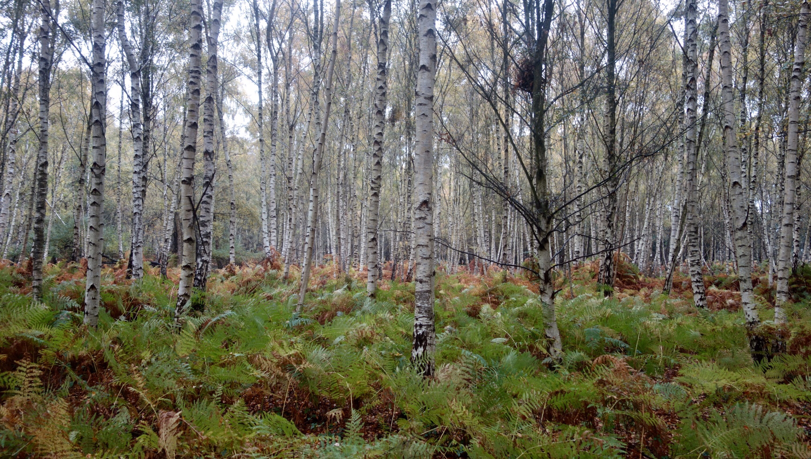

Ferrybridge, 0900
In horribly wet conditions we sought the “shelter” of the Chesil Beach Centre’s birdwatching platform and added a number of birds to the weekend list including Bar-tailed Godwit and Dark-bellied Brent Goose, the latter being several hundred strong. Our fish list started and finished here with a very fine Sea Bass brought in by a lucky fisherman.

Abbotsbury, 1000
The weather was still very wet as we reached the northern end of the Fleet so we decided to stay in the van and drive up and down looking for the Cattle Egrets that have been here for a week or so. The strategy worked excellently as we found a flock of 37 of these lovely birds, the biggest flock ever seen in Dorset.
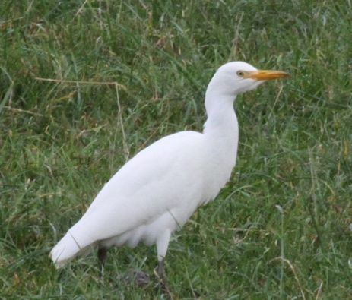
Cattle Egret (photo by John Thompson)

Arne RSPB Reserve, 1130
After lunch we walked out to Shipstall Point where we found lots of Curlews and a very impressive flock of around a thousand Avocets. We never did identify the species of seal that popped up in the channel in front of Round Island but we did recognise the distinctive sounds of a Sika stag in rut. On the way to the hide both woodpeckers were seen along with five or six Jays. At the hide the second and third Peregrines of the weekend were seen here as well as a range of waterbirds including Pintail, Common Scoter and Great Crested Grebe.

Portland Bill, 1600
We finished the weekend with another search for owls but it was still too windy. We did get very close views of a pair of Ravens though and the briefest of glimpses of a Merlin dashing past the Higher Light.

Back at the hotel over a cream tea we discovered that we had amassed a very respectable total of 90 species of birds, seen and heard.

Looking forward to the next time,

Bob

The weekend’s list of species:

Little Grebe Radipole
Great Crested Grebe Arne, Radipole
Gannet Portland Bill
Cormorant Arne, Radipole, Portland Bill
Shag Portland Bill
Grey Heron Lodmoor, Arne, Radipole,
Little Egret Ferrybridge, Lodmoor, Radipole, Arne
Cattle Egret Abbotsbury
Mute Swan Radipole
Canada Goose Lodmoor, Radipole
Dark-bellied Brent Goose Arne, Ferrybridge
Shelduck Arne, Radipole
Wigeon Arne
Teal Lodmoor, Arne, Radipole
Gadwall Radipole
Shoveler Lodmoor, Radipole
Mallard Lodmoor, Arne, Radipole
Pintail Arne
Tufted Duck Radipole
Pochard Radipole
Common Scoter Arne
Red-breasted Merganser Ferrybridge
Marsh Harrier Radipole
Peregrine Portland Bill, Arne, St John’s Church Weymouth
Merlin Portland Bill
Kestrel Portland
Buzzard Portland
Sparrowhawk Portland Bill
Pheasant Abbotsbury
Water Rail Radipole (heard)
Moorhen Lodmoor, Radipole
Coot Lodmoor, Radipole
Oystercatcher Portland Bill, Arne
Avocet Arne
Curlew Arne
Redshank Arne
Greenshank Lodmoor
Lesser Yellowlegs Lodmoor
Ringed Plover Ferrybridge
Black-tailed Godwit Lodmoor, Arne, Radipole
Bar-tailed Godwit Ferrybridge, Arne
Snipe Lodmoor, Radipole
Lapwing Lodmoor, Portesham
Dunlin Ferrybridge, Lodmoor
Turnstone Ferrybridge, Portland Bill
Black-headed Gull Ferrybridge, Lodmoor, Radipole, Arne
Mediterranean Gull Ferrybridge, Lodmoor, Radipole, Portland Bill
Herring Gull Portland etc
Glaucous Gull Portland Bill
Great Black-backed Gull Portland etc
Lesser Black-backed Gull Ferrybridge
Common Gull Ferrybridge, Lodmoor, Radipole
Little Gull Lodmoor
Kittiwake Portland Bill
Guillemot Portland Bill
Wood Pigeon Portland etc
Feral Pigeon Portland etc
Collared Dove Portland
Great Spotted Woodpecker Arne
Green Woodpecker Arne
Skylark Ferrybridge
Meadow Pipit Ferrybridge
Rock Pipit Portland Bill
Pied Wagtail Portland etc
Grey Wagtail Nottington
Wren Portland etc
Dunnock Portland etc
Robin Portland etc
Song Thrush Portland
Mistle Thrush Abbotsbury
Blackbird Portland etc
Cetti’s Warbler Radipole (heard)
Chiffchaff Radipole (heard)
Goldcrest Arne
Long-tailed Tit Radipole, Arne
Coal Tit Arne
Blue Tit Portland etc
Great Tit Portland etc
Jay Arne
Rook Portland, Abbotsbury
Magpie Portland etc
Jackdaw Portland etc
Carrion Crow Portland etc
Raven Portland Bill
Starling Portland etc
House Sparrow Portland
Chaffinch Portland, Radipole, Lodmoor, Arne
Goldfinch Portland, Radipole, Lodmoor
Linnet Portland, Ferrybridge, Lodmoor
Greenfinch Lodmoor

Mammals
Grey Squirrel Portland, Arne
British Primitive Goat Portland
lSeal spp Arne
Sika Arne

Fish
Bass Ferrybridge

Insects
Peacock Portland etc
Red Admiral Portland etc
Flame Brocade Portland Bird Observatory
Angle Shades Portland Bird Observatory
Large Yellow Underwing Portland Bird Observatory
Ichneumon Wasp Portland Bird Observatory
Common Wasp Portland Bird Observatory
Migrant Hawker Lodmoor

