Portland Heights Birdwatching Breaks November 7th - November 9th 2014

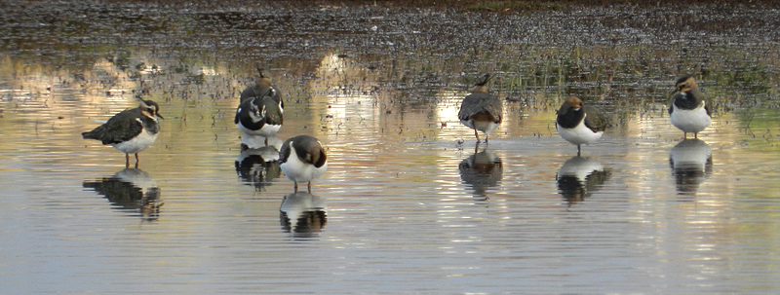
Saturday November 8th
Weather: light rain interspersed with occasional heavy downpours for most of the day, wind strong southerly

Portland Bill, 0900
It was with some trepidation that we started the day at the Bill expecting to get very cold and wet. In the event we kept dry for most of the time, helped by a spell in the Lobster Pot cafe. In fact we only get wet right at the end of our sea-watch when a Leach's petrel prevented us from leaving the Bill when we could see that the weather was about to take a turn fir the worst. Apart from this major find, the first ever seen on a Heights Birdbreak, we saw an excellent range of seabirds including gannets, Kittiwakes and guillemots. Not many land-birds were seen but a very late wheatear was an unexpected sighting and we had good close views of the resident rock pipits too.

Chesil Cove, 1200
A quick look in at the southern end of Chesil Beach failed to turn up the hoped-for little gull but we did see quite a few Mediterranean gulls instead.

Portland Castle, 1230
The south-western corner of Portland Harbour showed us an outstanding selection of birds including the long-staying black guillemot, the first red-breasted mergansers of the autumn and no less than two species of diver - a close black-throated and a distant great northern.

Ferrybridge, 1300
A wet and windy lunch-stop produced a good range of shorebirds with dunlins, ringed plovers, turnstones and a bar-tailed godwit feeding on the shores of the Fleet along with several hundred dark-bellied brent geese.

Radipole Lake RSPB Reserve, 1430
An outstanding end to the day. It's really very difficult to choose a highlight out of a trio of marsh harriers, a show-off kingfisher juggling a fish or the huge flock of starlings swirling around our heads. Amazing!

Sunday November 9th
Weather: much brighter, but with several heavy showers, wind light westerly

Tout Quarry, 0700
Our early morning walk took us out to the Westcliffs in a fruitless search for ring ousels. Actually the search wasn't quite fruitless as we added raven buzzard and house sparrow to the weekend's list. As well as enjoying a very pleasant early morning.
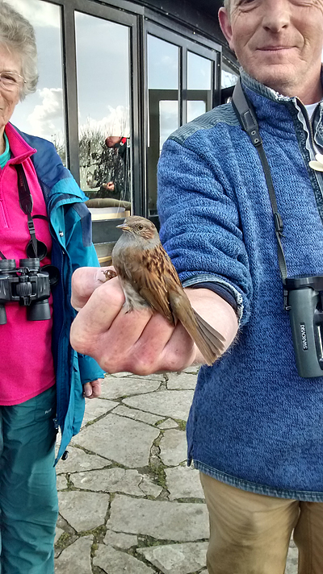
Portland Bird Observatory, 0930
As we arrived at PBO the warden produced a linnet in the hand. This was closely followed by a very smart chiffchaff. The nearby trees held a number of very pretty goldfinches but best of all was the excellent view we had of the little owl in the Observatory Quarry.

Ferrybridge, 1100
At high tide the Mediterranean gulls were very close as were the brent geese. The highlight though was the pair of female common scoter out on the Fleet.

Lodmoor RSPB Reserve, 1200
This brilliant reserve added quite a few new birds to the list including lapwing, gadwall and shoveler. Stonechat, Mediterranean gull and reed bunting were also seen but the highlight for me was the resident male marsh harrier appeared over the reedbeds.

Abbotsbury Beach, 1400
After an interesting adventure parking the bus we had a very pleasant lunch on Chesil Beach before walking up onto the beach to search for seabirds, producing just another two common scoter.

West Bexington, 1500
We all enjoyed the tranquility of this beautiful part of Dorset but very few birds were seen apart from a lone buzzard and a couple of long-tailed tits.

Abbotsbury Village, 1600
We finished the day with a search for a firecrest in the village car park, a search which came very close to succeeding with a firecrest positively identified by call but never seen satisfactorily in the rapidly-failing light.

Looking forward to our next outing together,

Bob

for the online version of this report – with photos – see http://www.natureportfolio.co.uk/birdbreak/report/archive

Birds: 78 species
Black-throated Diver | Portland Harbour
Great Northern Diver | Portland Harbour
Little Grebe | Radipole, Lodmoor
Great Crested Grebe | Radipole
Leach's Petrel | Portland Bill
Gannet | Portland Bill
Cormorant | Portland Harbour
Shag | Portland Bill
Little Egret | Ferrybridge, Lodmoor
Grey Heron | Radipole, Lodmoor
Mute Swan | Radipole, Abbotsbury
Canada Goose | Lodmoor
Dark-bellied Brent Goose | Ferrybridge
Shelduck | Radipole, Lodmoor
Shoveler | Lodmoor
Teal | Radipole, Lodmoor
Mallard | Radipole, Lodmoor
Gadwall | Lodmoor
Tufted Duck | Radipole
Pochard | Radipole
Common Scoter | Ferrybridge, West Bexington
Red-breasted Merganser | Portland Harbour
Hooded Merganser | Radipole
Marsh Harrier | Lodmoor, Radipole
Kestrel | Various sites
Sparrowhawk | Abbotsbury
Buzzard | Portland, West Bexington
Water Rail | Radipole (heard)
Moorhen | Radipole, Lodmoor
Coot | Radipole, Lodmoor
Turnstone | Portland Bill, Ferrybridge
Oystercatcher | Ferrybridge
Lapwing | Lodmoor
Ringed Plover | Ferrybridge
Dunlin | Ferrybridge
Redshank | Radipole
Bar-tailed Godwit | Ferrybridge
Snipe | Radipole, Lodmoor
Kittiwake | Portland Bill
Black-headed Gull | various sites
Mediterranean Gull | various sites
Herring Gull | various sites
Great Black-backed Gull | various sites
Lesser Black-backed Gull | Radipole, Lodmoor
Common Gull | various sites
Guillemot | Portland Bill
Black Guillemot | Portland Harbour
Wood Pigeon | various sites
Feral Pigeon | various sites
Stock Dove | Portland
Little Owl | Portland
Skylark | Portland Bill
Kingfisher | Radipole
Rock Pipit | Portland Bill
Pied Wagtail | various sites
Wren | various sites
Dunnock | various sites
Robin | various sites
Stonechat  Wheatear | Portland, Lodmoor  Portland Bill
Blackbird | various sites
Song Thrush | Portland Bill
Bearded Tit | Radipole (heard)
Blue Tit | various sites
Great Tit | various sites
Long-tailed Tit | various sites
Cetti's Warbler | Radipole (heard)
Chiffchaff | Portland Bill
Raven | Portland
Magpie | various sites
Jackdaw | various sites
Rook | various sites
Carrion Crow | various sites
Starling | various sites
Rose-coloured Starling | Southwell
House Sparrow | Portland Heights
Goldfinch | Portland
Linnet | Portland
Chaffinch | Portland, Lodmoor
Chaffinch | Portland, Lodmoor
Reed Bunting | Lodmoor
Photos by Chris Colles:



