Portland Heights Birdwatching Break Oct 11th – Oct 13th 2013

Saturday 12th October
Weather: a bit drizzly first thing, then dry and sunny for the rest of the day.

Portland Bill 0730
A cold and breezy Portland Bill gave us a good start to the weekend with a splendid barn owl easily the best bird. A brief view of a female merlin was the start of a succession of good bird of prey sightings which included a couple of sparrowhawks and several kestrels. The five or six red wings we saw were the first of the autumn for most of us.

Furzebrook 1100
This lovely site certainly produced the goods with a flock of fieldfares and three different Dartford warblers seen in quick succession. A pair of stonechats were of great help in showing us where the Dartfords were. The other highlight was the green woodpecker sunbathing in a distant bush out on the Heath.

Arne RSPB Reserve 1230
Another Dartford warbler was seen here on the walk out to Middlebere Lake. This inlet of Poole Harbour was alive with birds including hundreds of black-tailed godwits. The buzzard and peregrine seen here brought our raptor list up to a very respectable five. As usual this amazing reserve showed plenty of other wildlife including a herd of sika deer and a most impressive raft spider.

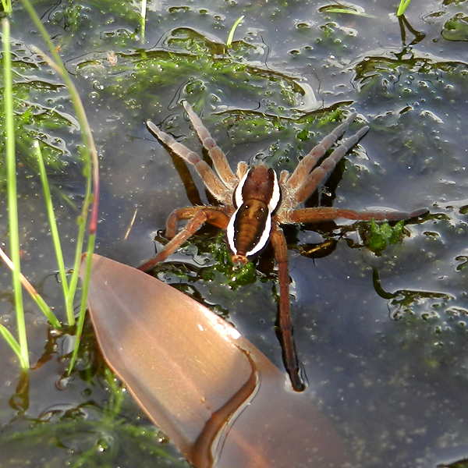
Raft Spider

Sunday 12th October
Weather: a cool and breezy morning followed by a wet afternoon.

Tout Quarry 0730
Plenty of thrushes had arrived overnight with several redwings, a couple of song thrushes and lots of blackbirds. No ring ousels though. Overhead we could hear siskins flying east and we could see groups of swallows flying – north! On the ground large numbers of finches were feeding on the brambles and teasels, mostly goldfinches and linnets with a few chaffinches. Over the cliffs a pair of ravens drifted past and a peregrine hunted pigeons.

Portland Bill 1000
The Bill itself produced just a few seabirds in this unproductive north-easterly wind, namely a few gannets, a few more Mediterranean gulls and a guillemot or two. The best sighting here was the large bull grey seal just offshore. On the land were plenty of meadow pipits and a few wheatears. Walking along the Westcliffs we saw very little apart from several huge fox moth caterpillars and a beautiful little puffball.

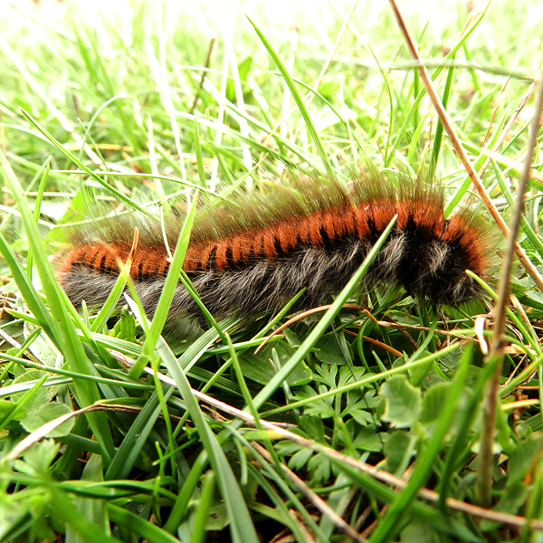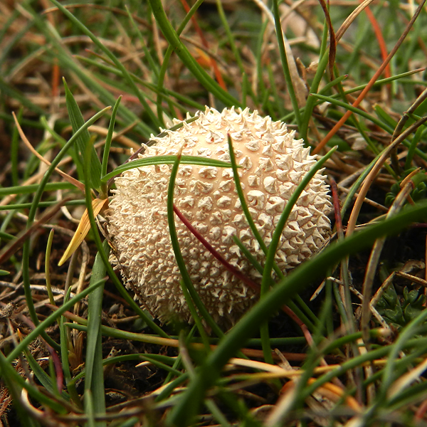

Turning back through the Topfields we found about five skylarks but sadly no sign of the short-toed lark. Noticing that there appeared to be a degree of ringing still going on we called in to the Bird Observatory where we were shown a chiffchaff and a female common redstart in the hand.
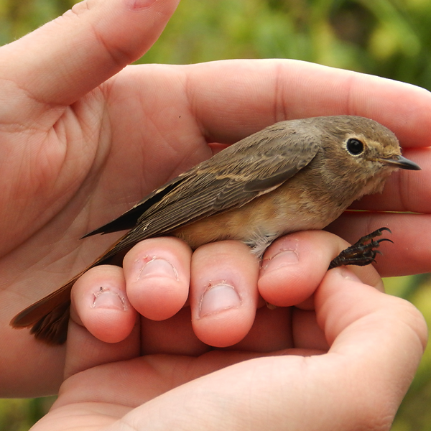 | 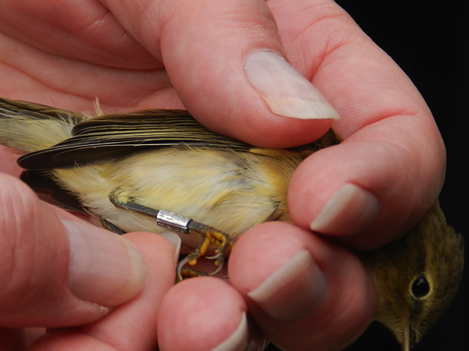

Southwell 1200
Searching for a yellow-browed warbler we found a few chiffchaffs and heard a goldcrest but little else.

Ferrybridge 1300
A much more productive stop with five bar-tailed godwits and a very smart brent goose as well as a real surprise sighting – a brown hare running along Chesil Beach.

Portland Castle 1400
A guillemot was found in the marina and more chiffchaffs in the grounds of the Castle. A sharp call from the sycamores here was almost certainly a yellow-browed warbler but we couldn't track it down to confirm it properly.

Radipole Lake RSPB Reserve 1500
A host of new species here including excellent views of snipe, water rail and green sandpiper. Bearded tits and Cetti's warblers were heard but not seen.

At our cream tea back at the hotel we counted up a very impressive total of 94 species seen or heard. Looking forward to the next time,

Bob Ford
http://www.dorsetwalks.com

Birds: 94 species
Little Grebe | Radipole
Great Crested Grebe | Radipole
Gannet | Portland Bill
Cormorant | various sites
Shag | Portland Bill
Little Egret | Ferrybridge, Arne
Grey Heron | Radipole
Mute Swan | Radipole
Canada Goose | Radipole
Brent Goose | Ferrybridge
Shelduck | Radipole, Arne
Wigeon | Arne
Pintail | Arne
Gadwall | Radipole
Shoveler | Radipole
Teal | Radipole, Arne
Mallard | Radipole, Arne
Tufted Duck | Radipole
Hooded Merganser | Radipole
Pochard | Radipole
Buzzard | Portland, Arne
Kestrel | various sites
Peregrine | Portland, Arne
Merlin | Portland Bill
Sparrowhawk | Portland Bill
Water Rail | Radipole
Moorhen | Radipole, Arne
Coot | Radipole, Arne
Oystercatcher | Portland Bill
Ringed Plover | Ferrybridge
GreyPlover | Arne
Lapwing | Arne
Dunlin | Ferrybridge
Redshank | Arne
Green Sandpiper | Radipole
Curlew | Arne
Snipe | Portland Bill, Radipole
Black-tailed Godwit | Arne
Bar-tailed Godwit | Ferrybridge
Turnstone | Ferrybridge
Mediterranean Gull | Ferrybridge, Radipole
Common Gull | Portland Bill
Black-headed Gull | various sites
Herring Gull | various sites
Lesser Black-backed Gull | Radipole
Great Black-backed Gull | various sites
Pheasant | Poxwell
Guillemot | Portland
Wood Pigeon | various sites
Feral Pigeon | Weymouth
Stock Dove | Arne
Collared Dove | Portland
Barn Owl | Portland
Kingfisher | Arne
Green Woodpecker | Arne
Great-spotted Woodpecker | Arne
Swallow | Portland
House Martin | Portland
Meadow Pipit | various sites
Rock Pipit | Portland Bill
Pied Wagtail | various sites
Grey Wagtail | Radipole
Skylark | Portland Bill
Wren | Portland
Dunnock | various sites
Robin | various sites
Stonechat | Furzebrook, Radipole, Arne
Redstart | Portland Bird Observatory
Wheatear | Furzebrook, Portland
Redwing | Portland
Fieldfare | Furzebrook
Blackbird | various sites
Cetti's Warbler | Radipole (heard)
Chiffchaff | various sites
Blackcap | Portland
Dartford Warbler | Furzebrook, Arne
Goldcrest | Arne
Long-tailed Tit | Arne (heard)
Bearded Tit | Radipole (heard)
Coal Tit | Arne
Blue Tit | various sites
Great Tit | various sites
Nuthatch | Arne
Jay | Arne (heard)
Raven | Portland
Magpie | various sites
Jackdaw | various sites
Rook | Arne
Carrion Crow | various sites
Starling | various sites
House Sparrow | various sites
Chaffinch | Arne, Portland
Greenfinch | Portland
Goldfinch | various sites
Linnet | Portland
Siskin | Portland
Butterflies:
Red Admiral | Portland
Large White | Portland
Clouded Yellow | Arne
Speckled Wood | Radipole
Moths:
Fox Moth | Portland

Oth Other Inverts:
Small White
Common Darter | Arne
Migrant Hawker | Arne
Emperor | Arne
Wood Ant | Arne
Raft Spider | Arne
Garden Cross Spider | Arne

Mammals:
Sika Deer | Arne
Roe Deer | Arne
Grey Seal | Portland Bill
Grey Squirrel | Arne
Brown Hare | Ferrybridge
Bunny | Portland

Amphibians:
Frog | Arne

